NATIONAL ASSOCIATION OF CONSERVATION
LAW ENFORCEMENT CHIEFS

Introduction to Conservation Leadership Academy
Application
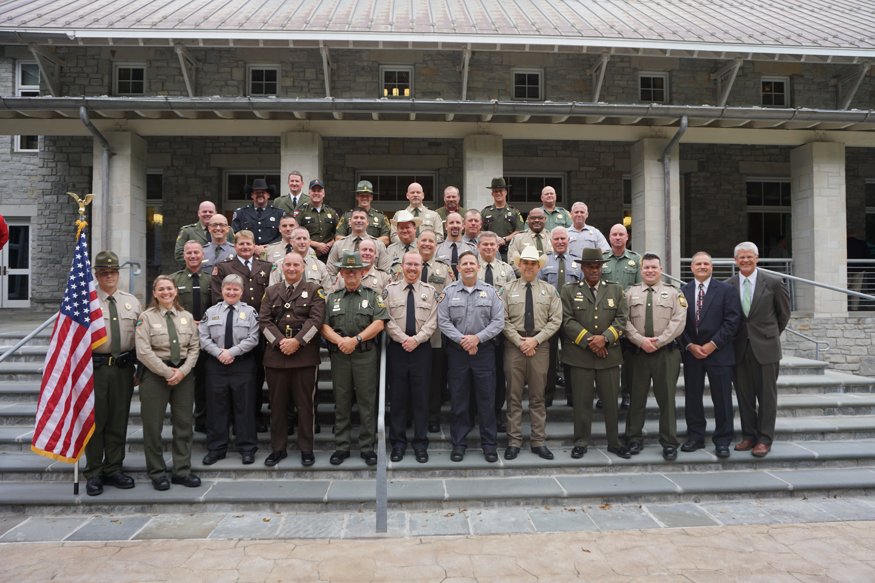

Best leadership and professional development training I've ever had, bar none. Thank you all for this incredible earning experience. I was skeptical at first but by the end of the week it was very clear to me how much I'd learned and how much this training influenced my personal development.

Attendee from 2022 ICL Cohort

August 4-10, 2024 (Includes travel dates)
National Conservation Training Center Shepherdstown, West Virginia

National Conservation Law Enforcement Leadership Academy

The goal of the Introduction to Conservation Leadership experience (ICL) is to prepare the next generation of conservation law enforcement officers to successfully carry out the conservation law enforcement mission in a
rapidly changing world.

The ICL focus is to provide an educational experience to officers early in their career on contemporary issues, future trends, adaptive leadership, self-awareness and other skills, knowledge, and abilities that will be key to success for those in conservation law enforcement leadership roles in the future.

“

Learned more from this course than from any other leadership course I have ever taken!!
Attendee, 2022, ICL

One of the best trainings I have ever been to. I really see how training first-line supervisors in adaptive leadership, not just chiefs, will better allow for progress within natural resources agencies.
Attendee, 2022, ICL

This is the first leadership course that I have attended that challenged me mentally, this was not something that I could have absorbed by way of reading alone.
Attendee, 2022, ICL

Training Tomorrow’s
Leadership Today

Specific Topics Include:

- Adaptive Leadership
  - Enhancing Self-Awareness & Personal Leadership Capacity
- Strengthening Relationships and Impact Networking

Applied Learning Project:

An integral aspect of the learning experience involves participants
working on a project that applies what is learned in the academy to a contemporary adaptive challenge. Participants will select an applied learning project on an adaptive challenge and work on making progress on that challenge back in their respective agencies.

Application Guidelines / Information

Application Guidelines

To participate in this leadership training program, applicants should:
- Be early in their career as field officer (2-8 years of experience optimal) or a first line supervisor (1-6 years of experience as a supervisor optimal).
- Be employed by a local, state, tribal or federal conservation law enforcement agency
- Have the endorsement of your agency’s Chief Executive
Applications must include:
- Administrator endorsement.
- Completed application.
- Written personal narrative (see below for details).
- Application deadline: 4:30PM on May 3, 2024

Cost
- $2,250.00 per student for agencies who are current NACLEC Members
- $2,750.00 for agencies who are not current NACLEC Members
- Tuition includes all meals, lodging at NCTC and all instructional costs
Note: Agencies are responsible for all travel costs to and from the National Conservation Training Center in Shepherdstown, WV.

Training Schedule
• August 4-10, 2024 (Includes Travel Dates)

Training Location:
National Conservation Training Center (NCTC)
Shepherdstown, West Virginia
For more information go to http://nctc.fws.gov

NATIONAL ASSOCIATION OF CONSERVATION
LAW ENFORCEMENT CHIEFS
The goal of the National Association of Conservation Law Enforcement Chiefs (NACLEC) ICL program is to prepare early career, next generation of conservation law enforcement officers with the leadership capacity to successfully carry out the conservation law enforcement mission in a rapidly changing world. The ICL focus is to provide an introductory educational experience to early career field officers and first line supervisors focused on contemporary issues, future trends, and adaptive leadership.

ICL fellows will be engaged in adult learning related to adaptive leadership. The ICL is student-centered with a high degree of student involvement and experiential learning.

Asynchronous Work

There is an online (asynchronous) learning component in the ICL experience. Participants will begin online learning activities 4-5 weeks prior to the residency beginning at the National Conservation Training Center. Online participation is a critical element in everyone’s academy learning experience. It provides a foundation for the academy experience. Completing online work will require an investment of roughly 2-3 hours per week in the 4-5 weeks prior to arriving at the academy.
Program cost: $2,250.00 per student for NACLEC Member Agencies / $2750.00 for Non-Member Agencies  - Includes all meals, lodging at NCTC & all instructional costs  Tuition payable to the National Association of Conservation Law Enforcement Chiefs no later than:  - July 15, 2024  Do not send any money now - NACLEC will invoice your agency after the applicant has been accepted into the program. |  |  |  | Course Dates:  August 4-10, 2024 (travel dates inclusive)  All classes will be held at the National  Conservation Training Center in Shepherdstown, West Virginia.  Participants must attend all classes.
Administrator Endorsement
The candidate listed on this application is a member of my agency. He/she has met
the pre-requisites of this course and has my endorsement. By signing this application, I understand the
financial obligations my agency will incur should this applicant fail to complete the course.
Department Chief Executive (printed name) |  |  | Email Address |  | Phone
Signature of Authorized Official |  |  | Title |  | Date

Officer’s Name (Last, First, MI) |  |  |  |  | Rank
Officer’s E-mail Address |  |  |  |  | Cell Phone Number |  |  |  |  | Office Phone Number
Agency |  |  |  |  | Street Address/PO Box
City |  |  |  |  | State |  |  |  |  | Zip Code
Years with Agency |  |  | Years as a Supervisor |  |  |  | # of Staff You Supervise
Prior  Supervisory  Training | Course Title(s): |  |  |  |  |  | Dates(s) Completed:
NACLEC will be purchasing tactical shirts and t-shirts for all Academy Participants. Please check your shirt size from the selections below:
____Small ____Medium ____Large ____X-Large ____XX-Large ____XXX-Large F__ M__
APPLICATION NARRATIVE: Along with your application, you must also include a 2-3 page written personal narrative responding to the following questions: 1) Why you want to attend the Leadership Academy? 2) What and how you will contribute to the learning environment? and 3.) After reading the National Survey report entitled “Planning for the Future of Conservation Law Enforcement in the United States” what you believe are the three most significant challenges we face in conservation law enforcement in the future? 4). Upon self-reflection, tell us about one specific self-awareness related personal developmental goal you have identified that, if improved upon, you believe would enhance your leadership capacity? Please do not exceed three pages.
NACLEC Use Only – Emergency Contact Information
Name of Emergency Contact |  |  |  | Email Address |  |  |  | Phone Number
Please apply online at the NACLEC website. If you have questions, please contact:
Randy Stark, NACLEC Executive Director
E-mail: starkr@charter.net
608-332-0176

Applications will be reviewed and participants selected by the NACLEC Leadership Academy Steering Team.
Applications MUST  be received by 4:30PM  on May 3, 2024 |  | Selected applicants will be notified by mid-May 2024. An invoice will be provided with the notification. |  |  |  |  |  |  | Questions:  Randy Stark, NACLEC Exec. Dir.  starkr@charter.net  608.332.0176
Applicant Commitment
I am committed to learning environment safety, developing my leadership capacity as an individual and on behalf of my agency, the institution of Conservation Law Enforcement and the natural resources in our country. I commit that:
- I will come to class on time and will actively participate in discussions.
- I will complete all course assignments and submit all course deliverables by the required deadlines.
- I will accept feedback and use it to improve my performance.
- I will participate in individualized coaching and accept feedback.
- I will provide honest and thorough program evaluations to the NACLEC Program with the goal of improving training for future law enforcement leaders.

Applicant Signature |  |  |  |  |  | Date

